CI/CD Lab Insem

Launch a Linux Virtual Machine in AWS and Access from Local Linux Machine
This guide walks you through the process of launching a Linux virtual machine (VM) on Amazon Web Services (AWS) and accessing it securely from a local Linux machine using SSH. AWS provides a service called EC2 (Elastic Compute Cloud), which allows users to create and manage virtual servers in the cloud.

Step 1: Login to AWS Management Console
1. Go to the AWS Management Console at https://aws.amazon.com/console.
2. Sign in using your credentials or create a new AWS account.
3. In the search bar, type 'EC2' and open the EC2 Dashboard.

Step 2: Launch a New EC2 Instance
1. Click on 'Launch Instance' from the EC2 Dashboard.
2. Provide a name for your instance.
3. Choose an Amazon Machine Image (AMI). For example, select 'Amazon Linux 2 AMI' or 'Ubuntu Server'.
4. Choose an Instance Type (e.g., t2.micro, which is free-tier eligible).
5. Create or select an existing key pair (important for SSH access).
6. Configure network settings and allow SSH (port 22) access.
7. Review and launch the instance.

Step 3: Verify Instance Status
After launching, go to the EC2 dashboard and ensure that your instance state is 'running'. You can also check the public IP address assigned to your instance.

Step 4: Set Permissions for Key File
If you downloaded a PEM key file (e.g., my-key.pem), you must restrict its permissions to make it secure.
Run the following command in your local terminal:
chmod 400 my-key.pem

Step 5: Connect to the Instance via SSH
Use the following command to connect to your instance:
ssh -i my-key.pem ec2-user@<public-ip-address>
For Ubuntu-based AMIs, the username may be 'ubuntu' instead of 'ec2-user'.

Step 6: Verify Connectivity
Once connected, you can run Linux commands directly on your AWS instance.
Example:
sudo yum update -y # For Amazon Linux
sudo apt update -y # For Ubuntu

Step 7: Optional - Transfer Files Between Local and AWS
You can use SCP (Secure Copy) to transfer files between your local machine and the AWS instance.
Example to upload a file:
scp -i my-key.pem myfile.txt ec2-user@<public-ip-address>:/home/ec2-user/
Example to download a file:
scp -i my-key.pem ec2-user@<public-ip-address>:/home/ec2-user/output.txt ./

Conclusion
You have successfully launched a Linux virtual machine on AWS and connected to it from your local Linux system. This process forms the foundation for cloud-based development, hosting, and deployment workflows.
Screen Shots for the process
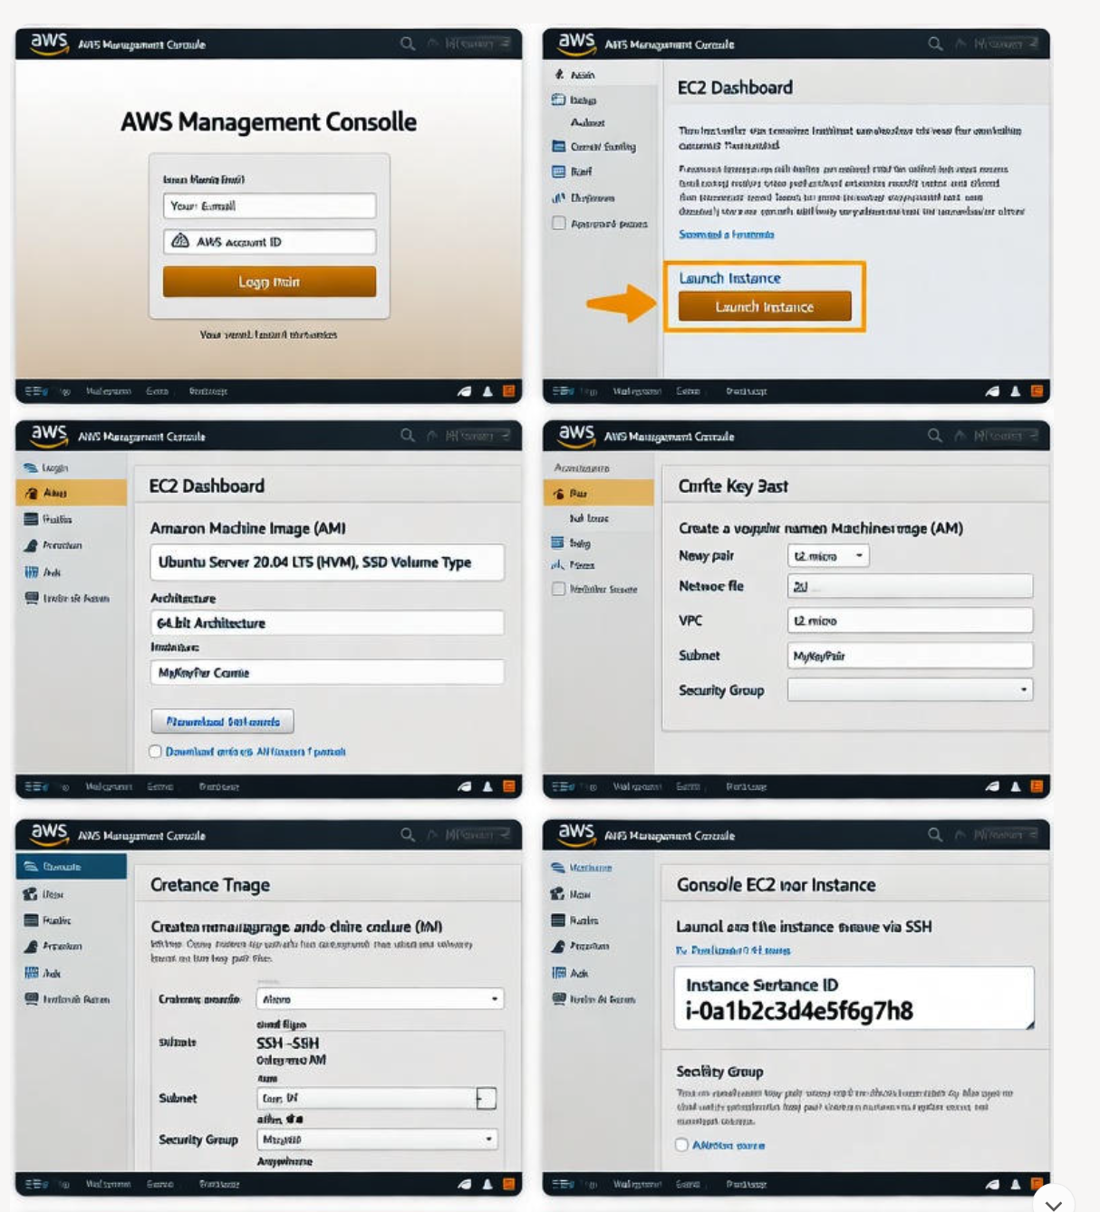
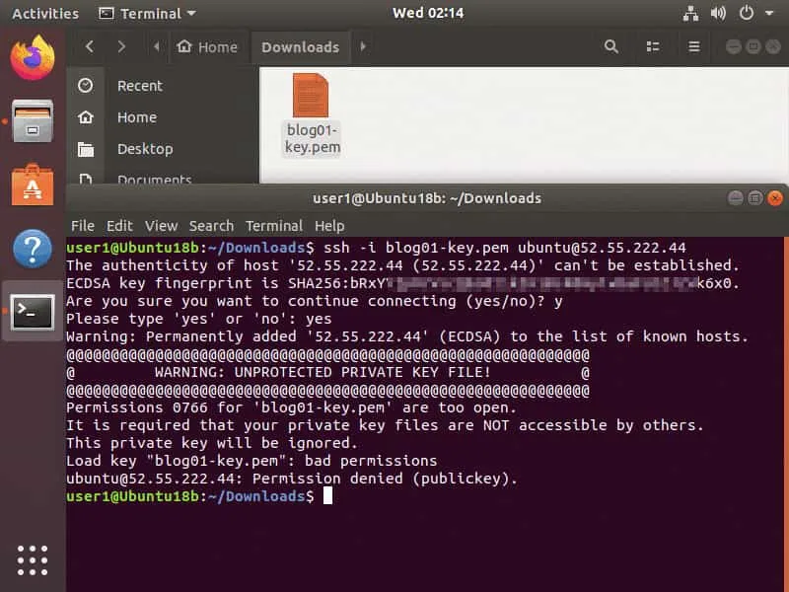
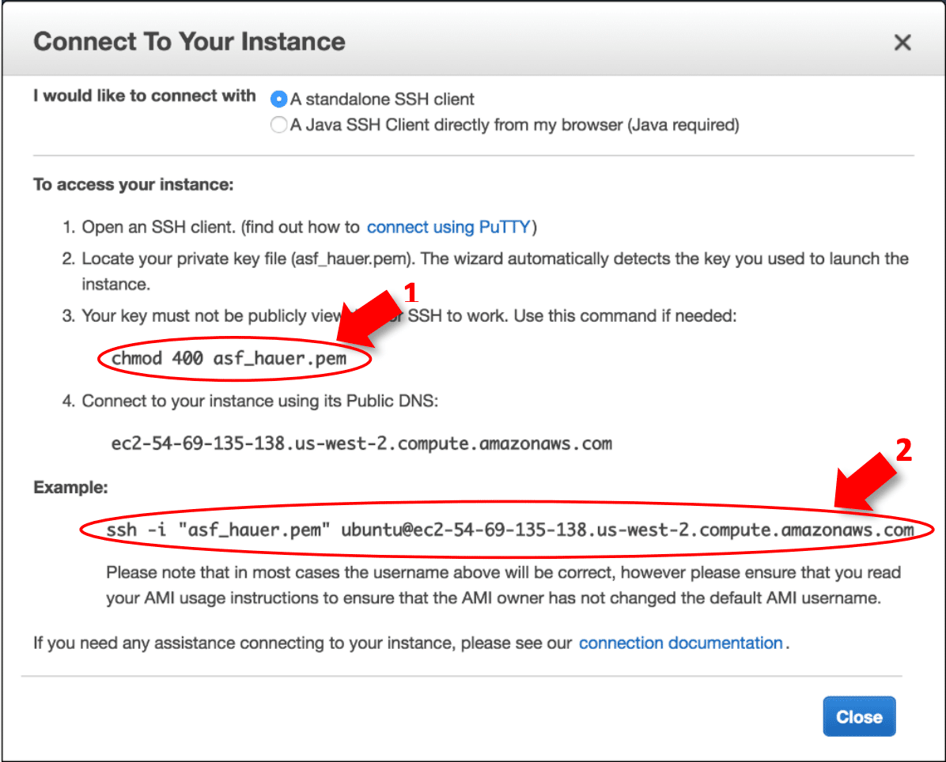
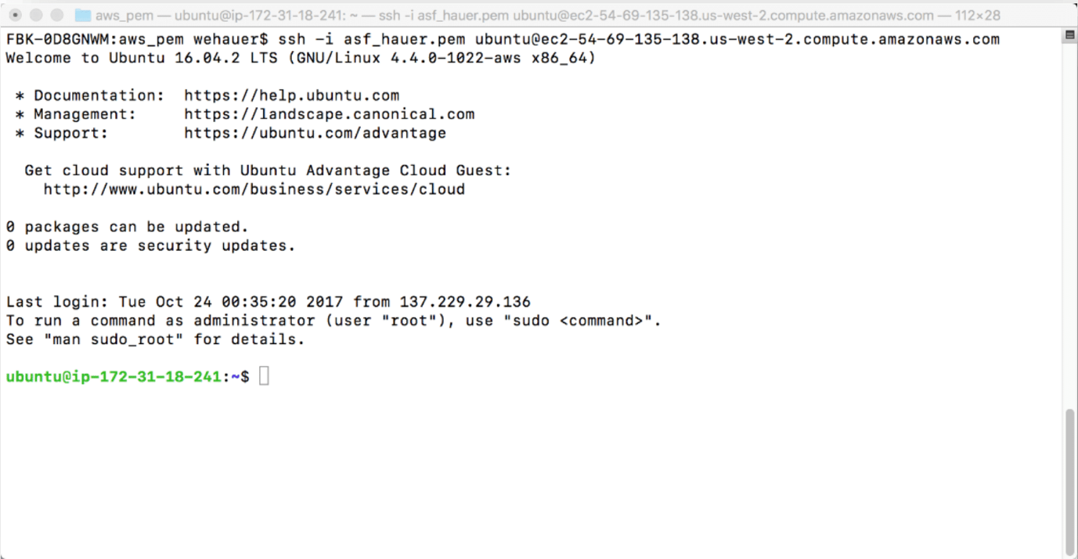
YouTube Link- https://www.youtube.com/watch?v=IFvsXeyYJvg

